DUAL AXIS SOLAR TRACKING SYSTEM WITH WEATHER DETECTION SENSOR

By

CHUKWUMA FUMNANYA DIVINE

A dissertation submitted in partial fulfilment of the requirements for the degree of

Bachelor of Science

In

Electronics and communication Engineering

30th November 2022

Supervisor:

Assoc. Prof. Dr. Yonal Kirsal

Table of Contents

Table of Contents ii

List of Figures iii Abstract iv

Declaration v

Acknowledgements vi

1 Introduction 1

1.1 Materials used in building the device...………………………..1

1.2 Software specifications………………………………………...2

2 Design Methodology and Discussions……………………………3

2.1 Arduino Uno Board…………………………………………….3

2.2 Solar Panel……………………………………………………..5

2.3 Servo Motors…………………………………………………..6

2.4 Stepper Motors………………………………………………..7

2.5 Rain Sensor…………………………………………………….8

2.6 Humidity Sensor……………………………………………….8

2.7 Resistors……………………………………………………….9

2.8 Capacitors……………………………………………………..10

2.9 BC547 Transistors…………………………………………….11

2.10 Cables and Connectors………………………………………11

2.11 1N4007 Rectifier Diodes…………………………………….12

2.12 Breadboards and PCBs…...………………………………….13

2.13 LED Bulb………….………………………………………...14

2.14 Transformer/Adapter………………………………………...15

2.15 Push Buttons…………………………………………………15

2.16 LCD Liquid Crystal Display………………………………...16

2.17 Software specification……………………………………….17

3 Methodology used in building this device………………………..20

4 Social Effects of the Project 29

4.1 Economical Analysis 29

4.2 Environmental benefits…………………………………….….29

4.3 Energy independence………………………………………….29

4.4 Economic benefits……………………………………………..29

4.5 Project budget………………………………………………….29

5 Conclusion 31

5.1 Future Work…………………………………………………..31

6 References 32

7 Gantt Chart………………..............................................................33

8 Poster……………………………………………………………...34

9 Graduation Project Proposal Form………………………………..35

List of Figures

Figure 1. Arduino Uno Board 3

Figure 2. I2C Communication………………………………………...…4

Figure 3. SPI Communication………………………………………...…5

Figure 4. Image of solar Panel…………………………………………...5

Figure 5. Servo Motor 9MDSM Brushless…………………………...…6

Figure 6. Stepper Motor………………………….……………………...7

Figure 7. Arduino Rain drop Sensor sen015………………………….....8

Figure 8. DHT22 AM2302 Digital Humidity Sensor……………………8

Figure 9. Resistors……………………………………………………….9

Figure 10. EEU-HD Electrolytic Capacitor…………………………....10

Figure 11. BC547 Transistor…….……………………………………..11

Figure 12. Cables and connectors………………………………………12

Figure 13. 1N4007 Rectifier Diode………………………………….…12

Figure 14. Breadboard……………………………………………….....13

Figure 15. PCB………………………………………………………....14

Figure 16. LED Bulb…………………………………………………...14

Figure 17. Adapter……………………………………………………...15

Figure 18. Push Buttons………………………………………………..15

Figure 19. Liquid Crystal Display (LCD)……………………………...16

Figure 20. LCD output screen………………………………………….16

Figure 21. Screenshot of Boot loader……………………………….18/19

Figure 20. Project Budget…………………………………………........30

Figure 21. Gantt chart……………………………………………….….33

Figure 22. Poster………………………………………………………..34

Abstract

In our modern age and time, solar power/energy is one of the fastest growing means of renewable energy. Nowadays it is implemented in various ways from solar powered vehicles to solar powered wind mills, to solar cooling and heating systems etc. and it is becoming the modern way to generate and maximise one of our biggest natural resource (*The Sun*). It became the alternative in electricity generation because of the problems faced in using fossil fuels. Experts don’t consider fossil fuels as renewable energy because their global supply is finite. The recent research on fossil fuels shows that it is likely to run out soon. Solar energy is renewable source and we will have a steady limitless supply of sunlight for another 5 billion years approximately. In one hour, the earth’s atmosphere receives enough sunlight/solar rays to power the electricity needs of every human being on earth for 365/366 days and compared to fossil fuels it is a clean source of energy no need for refinement unlike fossil fuels where by-products are dispersed and most of the time destroy other natural resources of our planet earth e.g. water bodies, Ozone layer (O3).

This project aims to add to the solar energy industry a device that harnesses the solar energy provided to use by the sun and uses it to power a weather detection device which would be able to tell its user once there is rain the temperature of the day and also how humid the atmosphere is. This device could be used in different places ranging from our homes to business offices to marketing shops etc.

Declaration

I understand the nature of plagiarism, and I am aware of the University’s policy on this.

I certify that this dissertation reports original work done by me during my University project

**Signature**: **Divine** **Date: 30th November 2022.**

Acknowledgements

First and foremost I would like to thank my supervisor Assoc. Prof. Dr. Yönal Kirsal who has given me a lot of encouragement, support and guidance. He has also given me constant motivation whenever I encountered a problem during throughout the duration of this project. I am also thankful for the advice given to me from other teaching staff of the department of Electronics and communication engineering.

# Introduction

This project is a combination of multiple sensors and input components that operate together to produce a weather detection device using solar energy for power. The name Dual Axis gives the solar panel responsible for harnessing the sun’s rays a 360 degree range of motion to be able to track and get the sun’s rays and it tracks the rays with its enabled movement by tracking where the photons in the atmosphere are concentrated. Using the energy acquired this device can be able to power the other components on the device such as the LCD display which is for displaying the weather condition at a particular moment, temperature sensor for detecting the temperature of the atmosphere, Humidity sensor for the detecting how Humid the atmosphere is, the servo and stepper motors responsible for the 360 degree range of motion of the solar panel. Also the energy harnessed from the sun will be used to power our arduino board which will be used to give instruction to all components involved using the C programming language. This device is a user friendly device and with more time and effort on it, it can be improved and also be able to handle other functionalities.

## MATERIALS USED IN MAKING THE DEVICE

* Atmega Microcontroller (Arduino Uno board)
* Solar panel
* Servo motor
* Stepper motor
* Rain sensor
* Humidity Sensor
* Resistor
* Capacitors
* BC547 Transistor
* Cables and connectors
* 1N4007 Rectifier Diode
* PCB and Breadboards
* LED
* Transformer/Adapter
* Push Buttons
* Switch
* IC
* IC Sockets
* Liquid Crystal Display (LCD)

## Software specifications

* Arduino Compiler
* C Programming Language

# Design components descriptions and Discussions

**2.1. Arduino Uno Board**

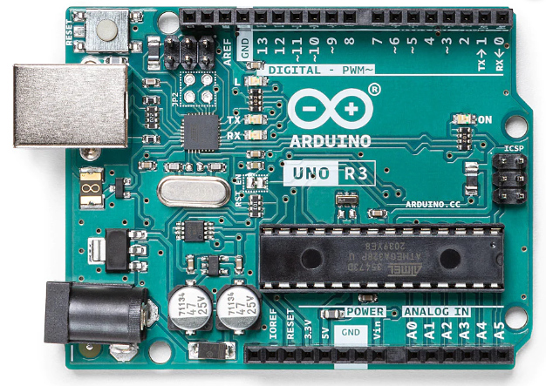

**Figure 1: Arduino Uno Board [4]**

A microcontroller board called Arduino Uno is based on the ATmega328P. It has a 16 MHz ceramic resonator (CSTCE16M0V53-R0), 6 analog inputs, 14 digital input/output pins (of which 6 can be used as PWM outputs), a USB port, a power jack, an ICSP header, and a reset button. It comes with everything required to support the microcontroller; to get started, just use a USB cable to connect it to a computer, or an AC-to-DC adapter or battery to power it [1].

**Specification:**

* USB Connection
* Clock Speed => 16MHz Ceramic Resonator
* LED_BUILTIN => 13
* 14 I/O Pins

**Communication :=>**

A computer, another Arduino board, or other microcontrollers can all be communicated with using the Arduino Uno's many communication features. On digital pins 0 (RX) and 1, the ATmega328 provides UART TTL (5V) serial connection (TX). This serial communication is routed through USB by an ATmega16U2 on the board, which is seen by computer software as a virtual com port. There is no external driver required because the 16U2 firmware works with the built-in USB COM drivers. On Windows, however, a.inf file is necessary. Simple textual data can be transmitted to and received from the board using the serial monitor found in the Arduino Software (IDE). When data is transmitted using the USB-to-serial chip and USB connection to the computer, the RX and TX LEDs on the board will flash (but not for serial communication on pins 0 and 1).

Any digital pin on the Uno can support serial communication thanks to the Software Serial library.

Communication over I2C (TWI) and SPI is also supported by the ATmega328. To make using the I2C bus simpler, the Arduino Software (IDE) contains the Wire library; check the documentation for more information. Use the SPI library to carry out SPI communication.

**Figure 2: I2C Communication [5] :=>**

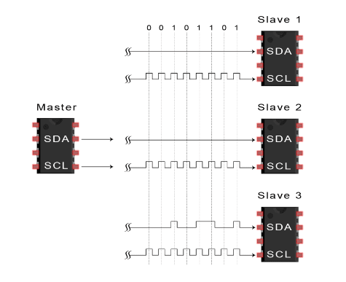

**Figure 3: SPI Communication [6] :=>**

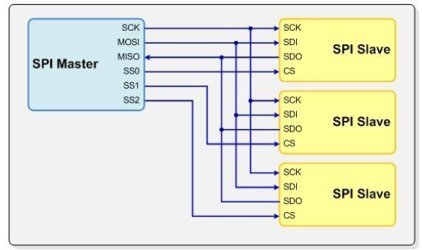

**2.2. Solar Panel**

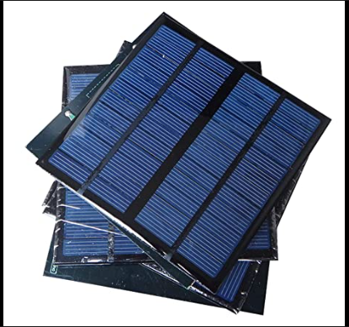

**Figure 4: Image of solar panels [7]**

Solar energy is generated by the sun. Solar panels, commonly referred to as "PV panels"(*Photovoltaic Panels*), are devices that utilise the sun's light, which is made up of tiny energy particles known as "photons," to create electricity that may be used to run electrical appliances.

In addition to producing electricity for household and commercial solar electric systems, solar panels can also be used for a wide range of other purposes, such as remote power systems for cabins, telecommunications equipment, remote sensing, and many others. They can be made into different shapes and sizes.[3]

**2.3 Servo Motors**

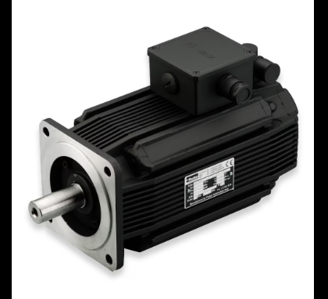

**Figure 5: Servo Motor 9MDSM Brushless [8]**

A servo motor is a self-contained electrical apparatus that rotates machine parts precisely and efficiently.

This motor's output shaft has movement capabilities that a typical motor does not, including the ability to move at a specific angle, location, and speed.

A conventional motor is used by the servo motor, and it is connected to a sensor to provide positional feedback.

The controller is the most crucial component of the servo motor employed for this specific function.

A closed-loop system called a servo motor uses positional feedback to regulate rotational or linear speed and position.

An electric signal, either analog or digital, is used to operate the motor and decides how much movement corresponds to the shaft's final command position.

Encoders can be used as sensors that provide feedback on speed and position. This electrical wiring is installed directly inside the motor housing, which is typically equipped with a gear system.

Servo motor types are divided into various categories according to how they are used, including AC and DC servo motors.

**2.4 Stepper Motors**

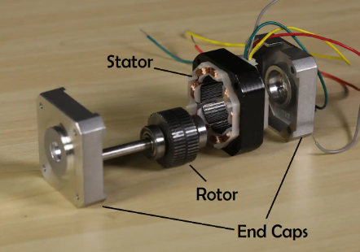

**Figure 6: Stepper Motor [9]**

A stepper motor (or step motor) is a brushless, synchronous electric motor that can divide a full rotation into a large number of steps. The motor's position can be controlled precisely without any feedback mechanism (see Open-loop controller), as long as the motor is carefully sized to the application. Stepper motors are similar to switched reluctance motors (which are very large stepping motors with a reduced pole count, and generally are closed-loop commutated.)

## Fundamentals of operation

Stepper motors operate differently from DC brush motors, which rotate when voltage is applied to their terminals. Stepper motors, on the other hand, effectively have multiple "toothed" electromagnets arranged around a central gear-shaped piece of iron. The electromagnets are energized by an external control circuit, such as a microcontroller. To make the motor shaft turn, first one electromagnet is given power, which makes the gear's teeth magnetically attracted to the electromagnet's teeth. When the gear's teeth are thus aligned to the first electromagnet, they are slightly offset from the next electromagnet. So when the next electromagnet is turned on and the first is turned off, the gear rotates slightly to align with the next one, and from there the process is repeated. Each of those slight rotations is called a "step", with an integer number of steps making a full rotation. In that way, the motor can be turned by a precise angle.

**2.5 Rain Sensor**

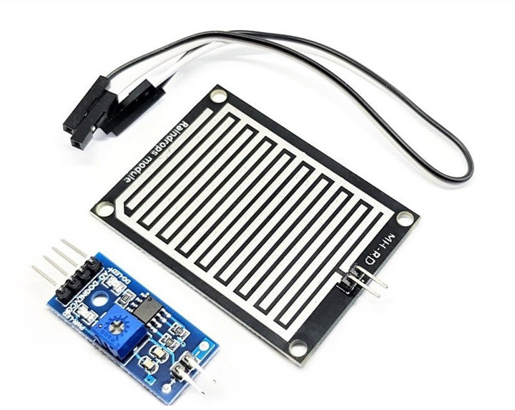

**Figure 7: Arduino Rain drop Sensor Sen015 [10]**

A switching device that is triggered by rainfall is known as a rain sensor or rain switch. For rain sensors, there are two main uses. The first is a water-saving gadget that is attached to an automatic irrigation system and causes it to turn off during a downpour. The second is a device that shields an automobile's interior from the elements and supports the automated windshield wiper function. In the case of this project’s device we it will be used to check for rain fall as well and the humidity and temperature degrees will be displayed on the LCD Display.

**2.6 Humidity Sensor**

[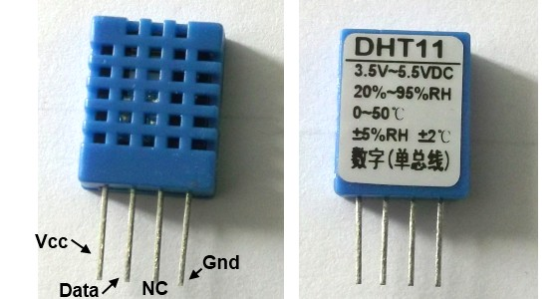](http://embedded-lab.com/blog/wp-content/uploads/2012/01/DHT11Sensor1.jpg)

**Figure 8: DHT11 [11]**

The DHT11 sensor comes in a single row 4-pin package and operates from 3.5 to 5.5V power supply. It can measure temperature from 0-50 °C with an accuracy of ±2°C and relative humidity ranging from 20-95% with an accuracy of  ±5%. The sensor provides fully calibrated digital outputs for the two measurements. It has got its own proprietary 1-wire protocol, and therefore, the communication between the sensor and a microcontroller is not possible through a direct interface with any of its peripherals. The protocol must be implemented in the firmware of the MCU with precise timing required by the sensor.

**2.7 Resistors**

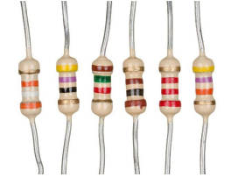

**Figure 9: Resistors [12]**

These control voltage division, signal levels, and electric current in an electronic circuit. Resistance is measured in ohms and is a component of many electronic circuits.

**2.8 Capacitors**

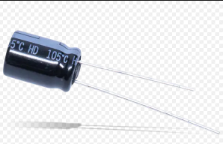

**Figure 10: EEU-HD Electrolytic Capacitor [13]**

A capacitor is a device that uses the accumulation of electric charges on two nearby surfaces that are electrically isolated from one another to store electrical energy in an electric field. It has two terminals and is a passive electrical component.

Capacitance refers to a capacitor's effect. While there is some capacitance between any two nearby electrical conductors in a circuit, a capacitor is a component made to increase capacitance.

**2.9 BC547 Transistor**

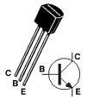

**Figure 11: Transistor BC547 [14]**

The BC547 transistor is an NPN Epitaxial Silicon Transistor. The BC547 transistor is a general-purpose transistor in small plastic packages. It is used in general-purpose switching and amplification BC847/BC547 series 45 V, 100mA NPN general-purpose transistors. The BC547 transistor is an NPN bipolar transistor, in which the letters "N" and "P" refer to the majority charge carriers inside the different regions of the transistor. Most bipolar transistors used today are NPN, because electron mobility is higher than whole mobility in semiconductors, allowing greater currents and faster operation. NPN transistors consist of a layer of P-doped semiconductor (the "base") between two N-doped layers. A small current entering the base in common-emitter mode is amplified in the collector output. In other terms, an NPN transistor is "on" when its base is pulled high relative to the emitter. The arrow in the NPN transistor symbol is on the emitter leg and points in the direction of the conventional current flow when the device is in forward active mode. One mnemonic device for identifying the symbol for the NPN transistor is "not pointing in." An NPN transistor can be considered as two diodes with a shared anode region. In typical operation, the emitter base junction is forward biased and the base collector junction is reverse biased. In an NPN transistor, for example, when a positive voltage is applied to the base emitter junction, the equilibrium between thermally generated carriers and the repelling electric field of the depletion region becomes unbalanced, allowing thermally excited electrons to inject into the base region. These electrons wander (or "diffuse") through the base from the region of high concentration near the emitter towards the region of low concentration near the collector. The electrons in the base are called minority carriers because the base is doped p-type which would make holes the majority carrier in the base.

**2.10 Cables and Connectors**

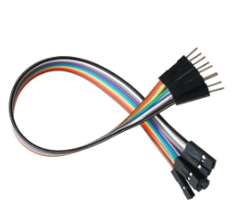

**Figure 12: Cables for arduino Connection**

There are many different types of electronics cabling, and cables are frequently incorporated into devices or made with a specific end-use in mind. Wherever wire lines need to be connected or detached, connectors are employed.

**2.11 1N4007 Diode**

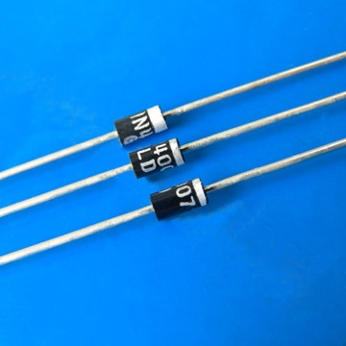

**Figure 13: 1N4007 Diode [15]**

Diodes are used to convert AC into DC these are used as half wave rectifier or full wave rectifier. Three points must he kept in mind while using any type of diode.

1. Maximum forward current capacity
2. Maximum reverse voltage capacity
3. Maximum forward voltage capacity

The number and voltage capacity of some of the important diodes available in the market are as follows:

* Diodes of number IN4001, IN4002, IN4003, IN4004, IN4005, IN4006 and IN4007 have maximum reverse bias voltage capacity of 50V and maximum forward current capacity of 1 Amp.
* Diode of same capacities can be used in place of one another. Besides this diode of more capacity can be used in place of diode of low capacity but diode of low capacity cannot be used in place of diode of high capacity. For example, in place of IN4002; IN4001 or IN4007 can be used but IN4001 or IN4002 cannot be used in place of IN4007.The diode BY125made by company BEL is equivalent of diode from IN4001 to IN4003. BY 126 is equivalent to diodes IN4004 to 4006 and BY 127 is equivalent to diode IN4007.

**2.12 Breadboards and PCB**

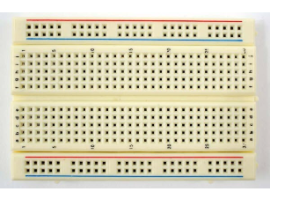

**Figure 14: Breadboard [16]**

Protoboards, also referred to as breadboards, are single- or double-sided solder less circuit boards with holes for attaching wires and component terminals. If necessary, you can alter them afterwards. Breadboards are widely accessible and are not project-specific.

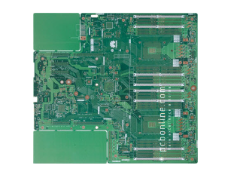

**Figure 15: PCBs [17]**

A hardware electrical board that provides circuit connection and support is referred to as a PCB, also known as a PWB or circuit card. Circuit boards are firmly attached to electronic components using solder.

**2.13 LEDs**

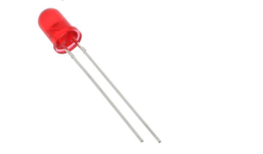

**Figure 16: LED Bulb**

These are small, powerful lights used in various applications.

Their polarity: Shorter leg: “-“. Longer leg: “+”

**2.14 12v Transformer/Adapter**

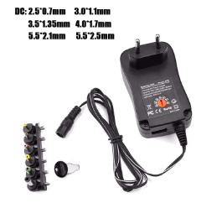

**Figure 17: Adapter**

While a converter or transformer transforms the voltage of the outlet per se, an adapter adapts to new outlets.

**2.15 Push Buttons**

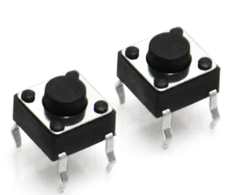

**Figure 18: Push Buttons**

**2.16 Liquid Crystal Display (LCD)**

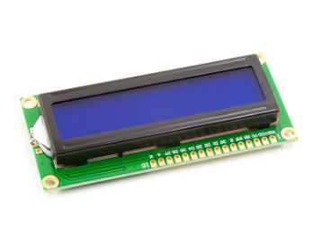

**Figure 19: LCD [2]**

This particular sort of display operates using a liquid crystal. There are 16 interfaces in all. It is a parallel interface, which implies that the microcontroller controls the LCD display by simultaneously operating many pins (Joshua Hrisko, 2017) [2].

Their pins:

The register that you choose regulates how data is stored in the display's memory.

Enable is a verb that is used to make writing to registers possible. When the mode is high, it transmits data to the data pins.

D0-D7 They are utilized to either set high or low VCC on data pins. The source of voltage

VEE

Pins for the back light.

The LCD output for this device is pasted below:

**Figure 20:** LCD output

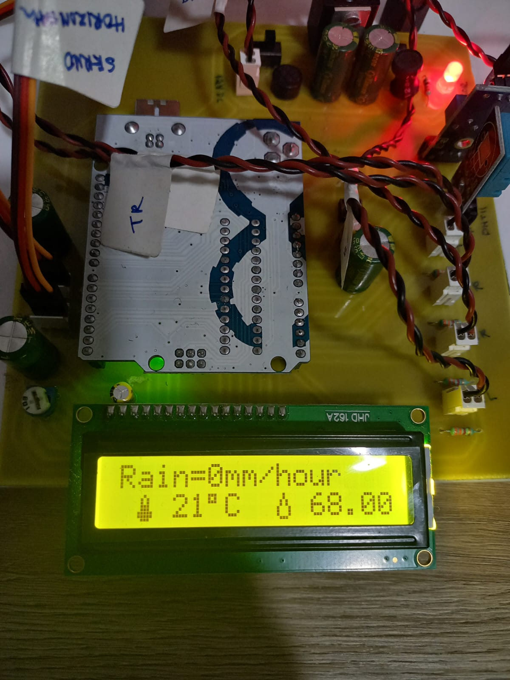

**2.17 Software Specifications**

**Arduino IDE**

The Arduino project provides the Arduino integrated development environment (IDE), which is a cross-platform application written in the programming language Java. It originated from the IDE for the languages Processing and Wiring. It is designed to introduce programming to artists and other newcomers unfamiliar with software development. It includes a code editor with features such as syntax highlighting, brace matching, and automatic indentation, and provides simple one-click mechanism to compile and load programs to an Arduino board. A program written with the IDE for Arduino is called a "sketch".

The Arduino IDE supports the languages C and C++ using special rules to organize code. The Arduino IDE supplies a software library called Wiring from the Wiring project, which provides many common input and output procedures. A typical Arduino C/C++ sketch consist of two functions that are compiled and linked with a program stub main() into an executable cyclic executive program.

After compiling and linking with the GNU toolchain, also included with the IDE distribution, the Arduino IDE employs the programavrdude to convert the executable code into a text file in hexadecimal coding that is loaded into the Arduino board by a loader program in the board's firmware.

Arduino programs may be written in any programming language with a compiler that produces binary machine code. Atmel provides a development environment for their microcontrollers, AVR Studio and the newer Atmel Studio, which can be used for programming Arduino.

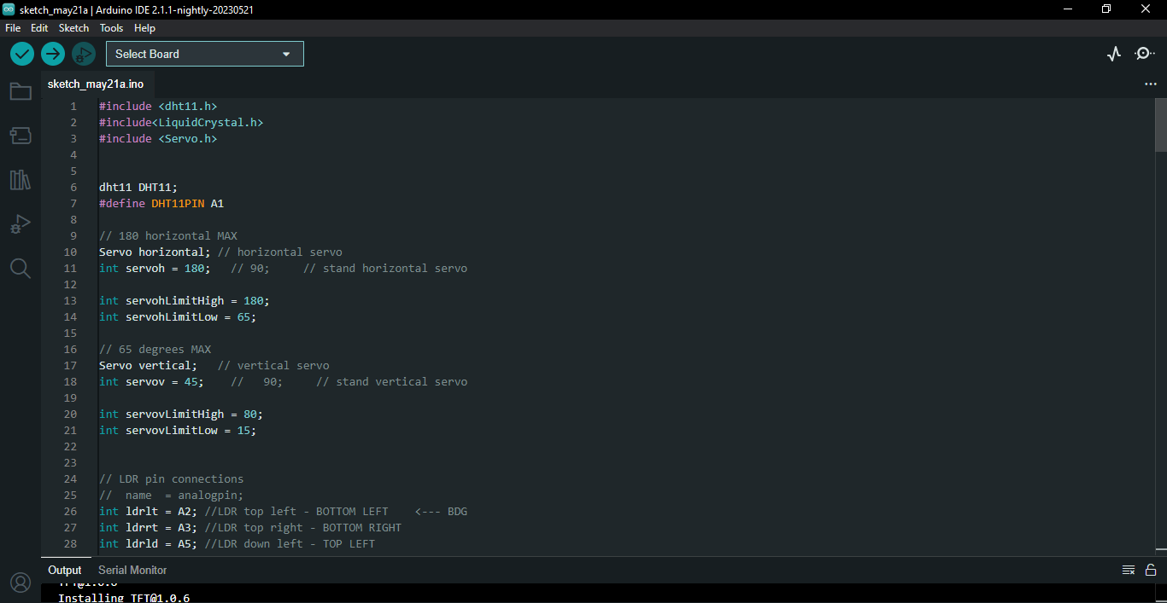

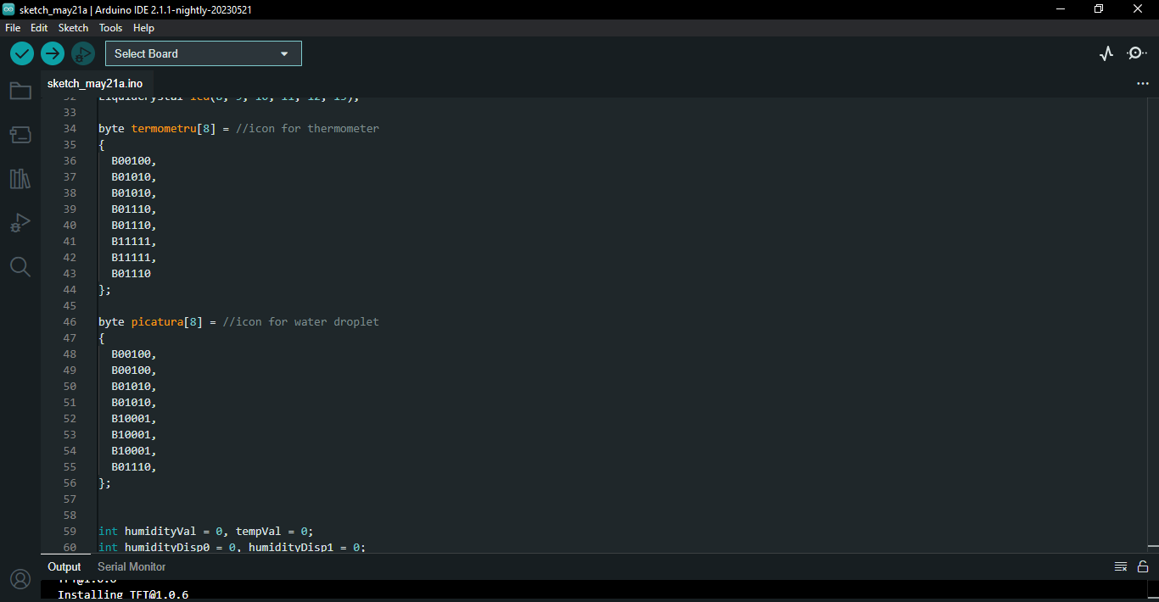

**Figure 21:** Screenshot of Boot loader.

# Methodology used in building this device

During the period of building this device I made sure to take my time and carefully map out the way to put the components together to maximise a good performance. Initially I built the frame for the solar panel that can rotate on both axes (vertical and horizontal) using servor and stepper motors to give the solar panel movement a universal 360 degrees range of motion. Next I installed 4 light dependent resistors LDRs on the frame next to each corner of the solar panel. These sensors will measure the light intensity and help the system to track the sun’s movement. I connected the LDRs to the analog inputs of the arduino board and used a voltage divider to adjust the LDRs output voltage to match the analog input range of the arduino. I calibrated the system by checking the LDR readings to ensure the LDRs are working perfectly. Thereafter I installed the arduino rain sensor and also I did the same for the DHT11 humidity sensor and connected them both to digital inputs on the arduino board. I thereafter inputted the code/instructions needed to run the system into the arduino board. The code is a tracking algorithm and runs in a closed-loop that gives instructions to each components to perform their tasks and track the sun’s movement. It reads data from components like the stepper and servo motors, LDRs, rain sensor, DHT11. The LDRs are kind of the main component when you talk about the sun tracking. The code takes the LDR readings as input and calculates the angle at which the solar panel should be positioned. Below is the code/sketch that I uploaded into the arduino board.

**CODE:**

#include <dht11.h>

#include<LiquidCrystal.h>

#include <Servo.h>

dht11 DHT11;

#define DHT11PIN A1

// 180 horizontal MAX

Servo horizontal; // horizontal servo

int servoh = 180; // 90; // stand horizontal servo

int servohLimitHigh = 180;

int servohLimitLow = 65;

// 65 degrees MAX

Servo vertical; // vertical servo

int servov = 45; // 90; // stand vertical servo

int servovLimitHigh = 80;

int servovLimitLow = 15;

// LDR pin connections

// name = analogpin;

int ldrlt = A2; //LDR top left - BOTTOM LEFT <--- BDG

int ldrrt = A3; //LDR top right - BOTTOM RIGHT

int ldrld = A5; //LDR down left - TOP LEFT

int ldrrd = A4; //LDR down right - TOP RIGHT

LiquidCrystal lcd(8, 9, 10, 11, 12, 13);

byte termometru[8] = //icon for thermometer

{

B00100,

B01010,

B01010,

B01110,

B01110,

B11111,

B11111,

B01110

};

byte picatura[8] = //icon for water droplet

{

B00100,

B00100,

B01010,

B01010,

B10001,

B10001,

B10001,

B01110,

};

int humidityVal = 0, tempVal = 0;

int humidityDisp0 = 0, humidityDisp1 = 0;

int b;

String weather_data;

int sensorValue = 0;

float rain = 0;

void setup() {

// put your setup code here, to run once:

Serial.begin(9600);

// servo connections

// name.attacht(pin);

horizontal.attach(5);

vertical.attach(6);

horizontal.write(180);

vertical.write(45);

// delay(3000);

lcd.begin(16, 2);

lcd.createChar(1, termometru);

lcd.createChar(2, picatura);

lcd.clear();

lcd.print("Dual Axis Solar ");

lcd.setCursor(0, 1);

lcd.print(" Tracking ");

delay(3000);

lcd.clear();

}

void loop() {

// put your main code here, to run repeatedly:

b = get_rain();

weather_data = String(b);

lcd.setCursor(0, 0);

lcd.print("Rain=");

lcd.print(weather_data);

lcd.print(F("mm/hour "));

humid_temp_read();

// delay(300);

int lt = analogRead(ldrlt); // top left

int rt = analogRead(ldrrt); // top right

int ld = analogRead(ldrld); // down left

int rd = analogRead(ldrrd); // down rigt

// int dtime = analogRead(4)/20; // read potentiometers

// int tol = analogRead(5)/4;

int dtime = 10;

int tol = 50;

int avt = (lt + rt) / 2; // average value top

int avd = (ld + rd) / 2; // average value down

int avl = (lt + ld) / 2; // average value left

int avr = (rt + rd) / 2; // average value right

int dvert = avt - avd; // check the difference of up and down

int dhoriz = avl - avr;// check the difference of left and right

Serial.print(avt);

Serial.print(" ");

Serial.print(avd);

Serial.print(" ");

Serial.print(avl);

Serial.print(" ");

Serial.print(avr);

Serial.print(" ");

Serial.print(dtime);

Serial.print(" ");

Serial.print(tol);

Serial.println(" ");

if (-1*tol > dvert || dvert > tol) // check if the difference is in the tolerance else change vertical angle

{

if (avt > avd)

{

servov = ++servov;

if (servov > servovLimitHigh)

{

servov = servovLimitHigh;

}

}

else if (avt < avd)

{

servov= --servov;

if (servov < servovLimitLow)

{

servov = servovLimitLow;

}

}

vertical.write(servov);

}

if (-1*tol > dhoriz || dhoriz > tol) // check if the difference is in the tolerance else change horizontal angle

{

if (avl > avr)

{

servoh = --servoh;

if (servoh < servohLimitLow)

{

servoh = servohLimitLow;

}

}

else if (avl < avr)

{

servoh = ++servoh;

if (servoh > servohLimitHigh)

{

servoh = servohLimitHigh;

}

}

else if (avl = avr)

{

// nothing

}

horizontal.write(servoh);

}

delay(dtime);

}

void humid_temp_read()

{

int chk = DHT11.read(DHT11PIN);

lcd.setCursor(1, 1);

lcd.write(1);

lcd.setCursor(3, 1);

tempVal = int(DHT11.temperature);

lcd.print(tempVal);

//Serial.println(tempVal);

lcd.setCursor(5, 1);

lcd.print((char)223); //degree sign

lcd.print("C");

lcd.setCursor(9, 1);

lcd.write(2);

lcd.setCursor(11, 1);

humidityVal = int(DHT11.humidity);

// humdityDisp0 = char(humdityVal);

// humidityVal = humidityVal / 10;

// lcd.print(humidityDisp0);

lcd.print((float)DHT11.humidity, 2);

//Serial.println(humidityVal);

lcd.print("%");

// delay(100);

}

int get_rain()

{

sensorValue = analogRead(A0);

// print out the value you read:

Serial.println(sensorValue);

rain = 0;

if ((sensorValue <= 1020) && (sensorValue > 500))

{

rain = map(sensorValue, 1020, 500, 0, 25);

}

else if ((sensorValue < 500) && (sensorValue >= 300))

{

rain = map(sensorValue, 500, 300, 26, 50);

}

else if ((sensorValue < 300) && (sensorValue >= 150))

{

rain = map(sensorValue, 300, 150, 51, 75);

}

else if (sensorValue < 150)

{

rain = map(sensorValue, 150, 0, 76, 100);

}

return rain;

}

Simulations of this device will be seen during device presentation by my authorities. I will post a picture of the device on the output section of the poster on page 31 of this report.

# Social Effects of the Project

There are a few ways this device affects the society:

**4.1. Environmental benefits**: One of the main social effects of a dual-axis solar tracking system is the positive impact it can have on the environment. Solar energy is a clean, renewable source of electricity that does not produce harmful greenhouse gases or other air pollutants. By using a solar tracking system, you can help to reduce your reliance on fossil fuels and lower your carbon footprint.

**4.2. Energy independence:** A dual-axis solar tracking system can help you to become more energy independent by generating your own electricity. This can be especially beneficial if you live in an area with high energy costs or unreliable electricity grids.

**4.3. Economic benefits:** A solar tracking system can save you money on your energy bills by reducing your reliance on the grid. It can also potentially increase the value of your home, as solar panels are becoming more popular with homebuyers.

**4.4. Education:** Building a dual-axis solar tracking system can be a great educational opportunity, as it involves learning about renewable energy, electricity, and engineering. It can also inspire others to learn more about solar energy and consider implementing similar systems in their own homes.

## 4.5. ECONOMICAL ANALYSIS

Below is a breakdown of the budget for this device:

|  |  |  |
| --- | --- | --- |
| ELECTRONIC COMPONENT | PRICE | WEBSITE |
| Arduino UNO Board | $6.02 | AliExpress |
| Solar panel 100w | $28.00 | AliExpress |
| Servo Motor | $3.00 | AliExpress |
| Stepper Motor | $3.00 | AliExpress |
| Arduino rain Sensor | $2.00 | AliExpress |
| DHT11 Humidity sensor | $3.00 | AliExpress |
| Resistor | $5.00 | AliExpress |
| Capacitors | $5.00 | AliExpress |
| BC547 Transistor | $3.00 | AliExpress |
| LCD | $7.00 | AliExpress |
| 1N4007 Diode | $2.75 | AliExpress |
| Breadboards and PCBs | $5.00 | AliExpress |
| LED Bulb | $6.00 | AliExpress |
| 12v Adapter/Transformer | $4.00 | AliExpress |
| Push Buttons | $2.50 | AliExpress |
| Switches | $2.00 | AliExpress |
| IC Sockets | $3.00 | AliExpress |
| TOTAL = $90.27 | | AliExpress |

**Figure 22: Project Budget**

# Conclusion

With this idea, a dual axis solar tracker coupled with a weather detector can be used in various places and departments. It can be a very vital device that replace sufficiently fossil fuel powered devices in weather detection and electricity provision.

The interface is user friendly and it consists of an interface that can guide it’s users through it. As a user knowing your weather condition can help you with rational decision making when making plans in your daily life.

## Future Work

In the future I would like to add a few upgrades to this device and one that I have thought of right now is a wireless smart phone charging function which will be able to make use of the energy harnessed from the sun by the solar panel to charge smart phones.

6. References

[1] Karl Soderby, 2021, A guide to arduino and I2C protocol <https://arduino.cc>

[2] Joshua Hrisko, 2017, Liquid Crystal Display and pixels, <https.www.makersportal.com>

[3] Power from the sun, 2013, (n.d). Retrieved from <https://powerfromthesun.net/book/>

[4] <https://store.arduino.cc/products/arduino-uno-rev3>

[5] <https://www.circuitbasics.com/basics-of-the-i2c-communication-protocol/>

[6] <https://www.corelis.com/education/tutorials/spi-tutorial/>

[7] <https://www.amazon.in/Sunnytech%C2%AE-250ma-Module-System-Charger/dp/B00Z2XC3B4>

[8] <https://ph.parker.com/us/en/series/brushless-servo-motors>

[9] <https://www.digikey.nl/en/blog/the-basics-of-stepper-motors>

[10] <https://electropeak.com/learn/interfacing-rain-drop-sensor-with-arduino/>

[11] <https://www.eeweb.com/temperature-and-relative-humidity-meter-using-an-inexpensive-dht11-sensor/>

[12]<https://www.autodesk.com/products/fusion-360/blog/how-to-choose-the-right-resistor/>

[13] <https://www.futureelectronics.com/p/passives--capacitors--aluminum-electrolytic-capacitors/eeuhd1v682-panasonic-6126615>

[14] <https://www.mifratech.com/public/blog-page/Water+level+indicator+using+BC+547+Transistor>

[15] <https://www.researchgate.net/figure/Fig-1N4007-diodes-The-number-and-voltage-capacity-of-some-of-the-important-diodes_fig12_294458539>

[16] <https://www.circuito.io/blog/breadboards/>

[17] <https://www.pcbonline.com/blog/breadboard-vs-pcb.html>

[18]

**7. GANTT CHART**

**Figure 23: Gantt chart**

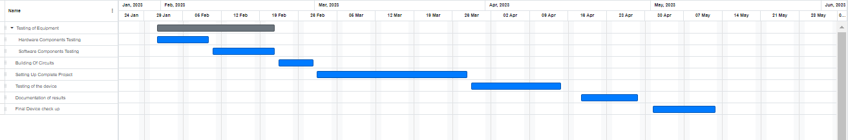

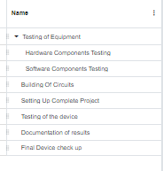

**8. POSTER**

**Figure 24: Poster**

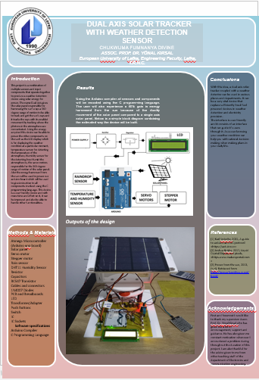

**EE410 GRADUATION PROJECT I PROJECT PROPOSAL FORM**

|  |  |  |
| --- | --- | --- |
| **Supervisor(s) Name & Surname** | **Assoc. Prof. Dr. Yonal Kirsal** | |
| **Supervisor Room Number** | **AS306** | |
| **Project Title** | **Dual Axis Solar tracking system with weather detection sensor** | |
| **Project Reference Number** | **ECE 409** | |
| **Teaching Discipline(s)** | **Electronics and Communication Engineering** | |
| **Are there any prerequisites for students?** | **No** | |
| **Project Summary:** | | |
| **The aim of this project is to maximise energy generation from the sun. The dual-axis tracker can increase energy by tracking sun rays by switching solar panels in various directions. The solar panel will have a 360-degree range of motion and will also have the characteristic or enablement to sense the weather condition wherever it is situated and display the weather condition on an LC Display. This device can be widely used worldwide in various places e.g. residential, industrial, and commercial environments. This device will include hardware components such as an LCD Display for displaying the weather condition it is situated in and also showing the humidity it also includes a temperature sensor, Humidity sensor, and rain sensor for weather condition detection. İt will also include a servo motor, stepper motor, and a solar panel to harness the sun’s energy.** | | |
| **Project Requirements:**  **It is vital that instrumentation, experimental equipment, computer software etc., be functional at the start of the project. Please indicate your requirements as follows:-** | | |
| 1. **Equipment service/repair calibration etc.** | **Yes** | |
| 1. **Technician effort prior to project** | **No** | |
| 1. **Technician effort during the project** | **No** | |
| 1. **Visits for data collection off-campus** | **No** | |
| 1. **Materials & other consumables** | **Atmega Microcontroller, Solar panel, Servo Motor, Stepper motor, Rain sensor, Humidity sensor Temperature sensor, Resistor, Capacitors, Transistors, Cables and connectors, diodes, PCB and breadboards, LED, Transformer/adapter, Push buttons, Switch, IC, IC Sockets, Arduino Compiler, C Programming Language.** | |
| **APPROVAL OF PROPOSAL:** | | **Date & Signature** |
| **Student (s)**  **1. CHUKWUMA FUMNANYA DIVINE**  **2. .................................................................................**  **3. .................................................................................**  **4. .................................................................................** | | **Divine** |
| **28th October, 2022** |
|  |
|  |
| **Supervisor (s)**  **Assoc. Prof. Dr. Yonal Kirsal** | | **31/10/2022** |